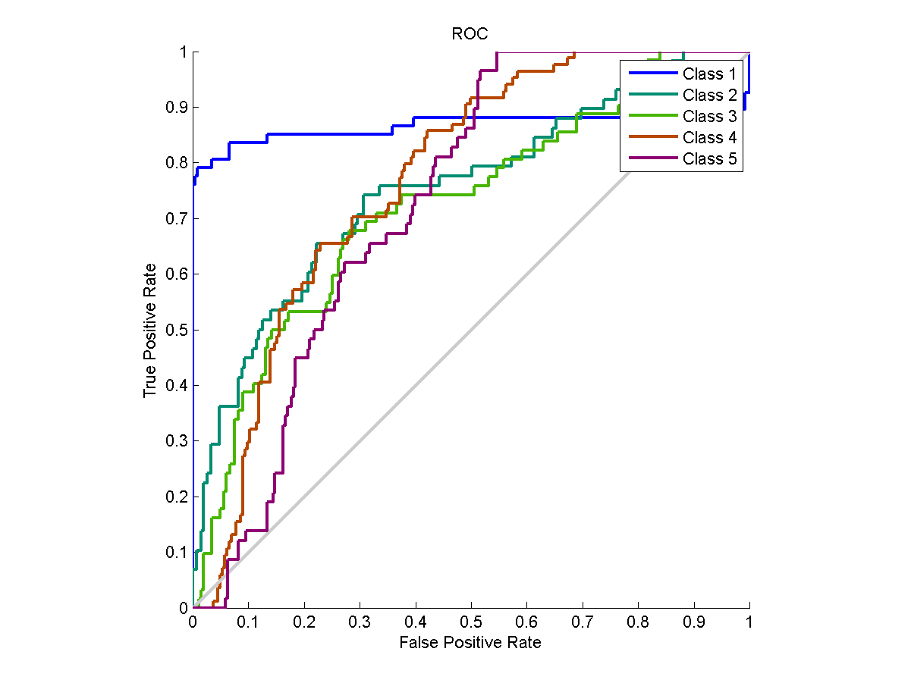

**Figure: ROC Curve using training Function = traingd.**

**Performance = 0.8078, trainPerformance = 0.7126, valPerformance = 0.5618, testPerformance = 0.5622**

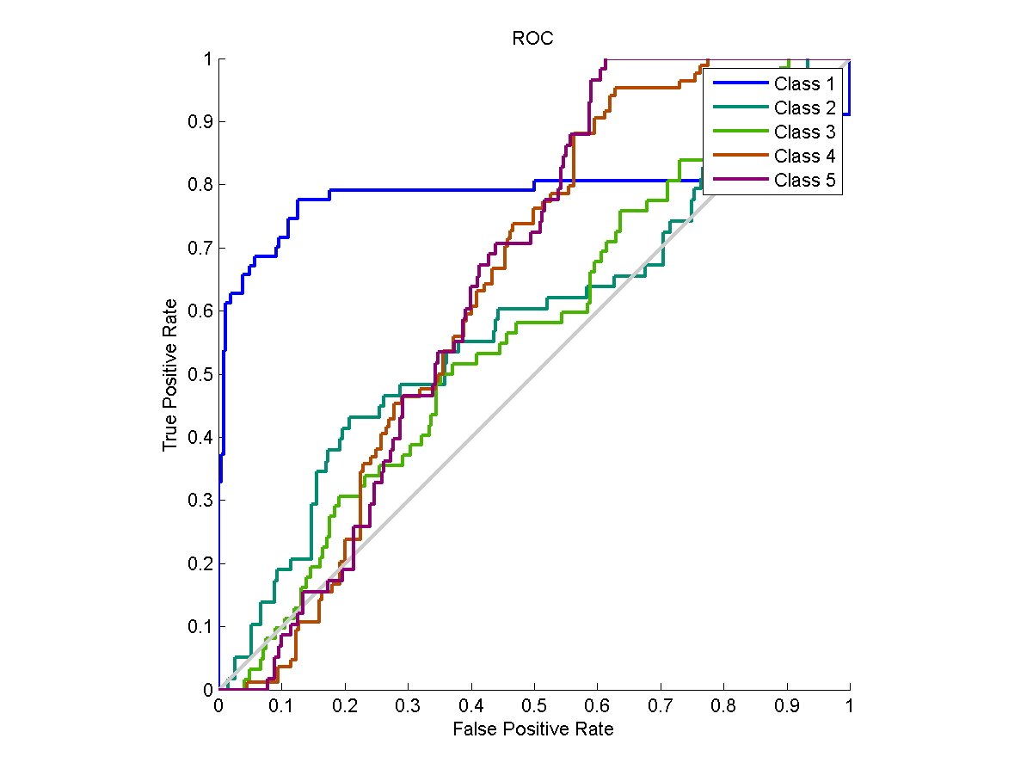

**Figure: ROC Curve using training Function = traingda.**

**Performance = 0.8234, trainPerformance = 0.7276, valPerformance = 0.5605, testPerformance = 0.5612**

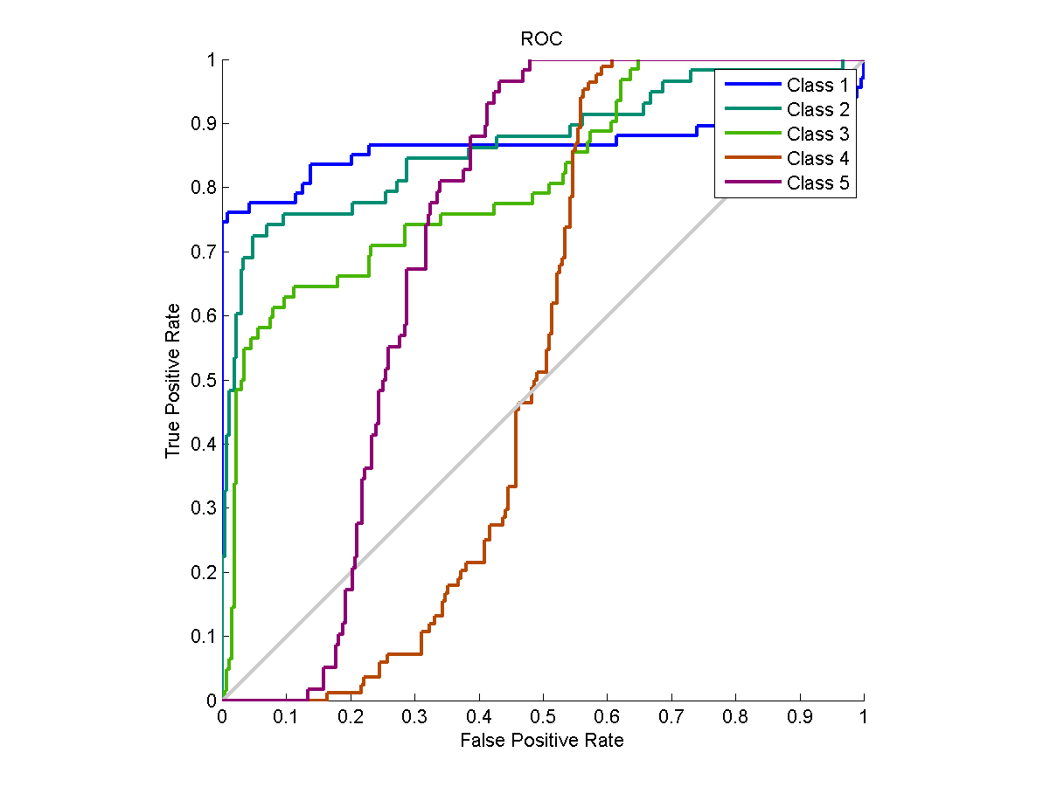

**Figure: ROC Curve using training Function = trainscg.**

**Performance = 0.8093, trainPerformance = 0.7144, valPerformance = 0.5633, testPerformance = 0.5649**

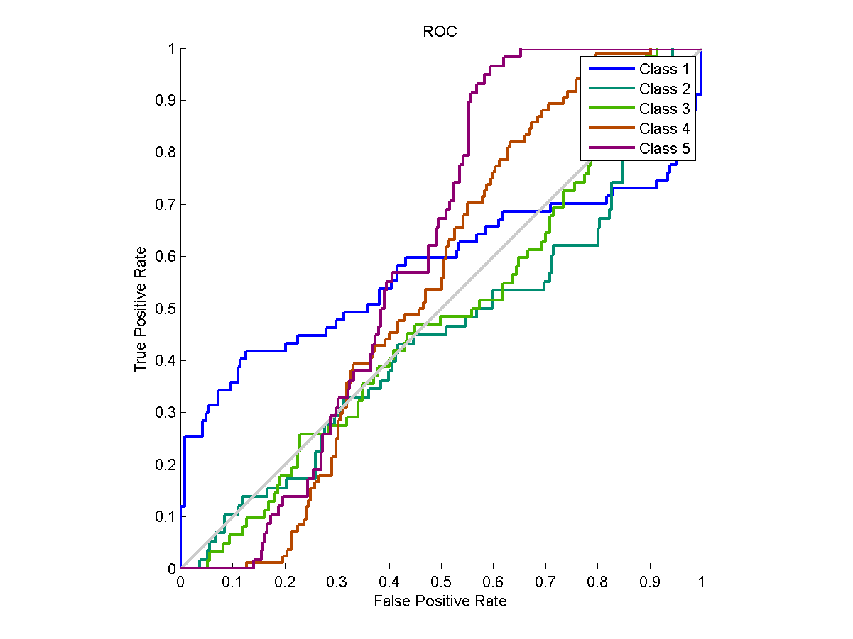

**Figure: ROC Curve using training Function = traingdm.**

**Performance = 0.8421, trainPerformance = 0.7430, valPerformance = 0.5616, testPerformance = 0.5648**

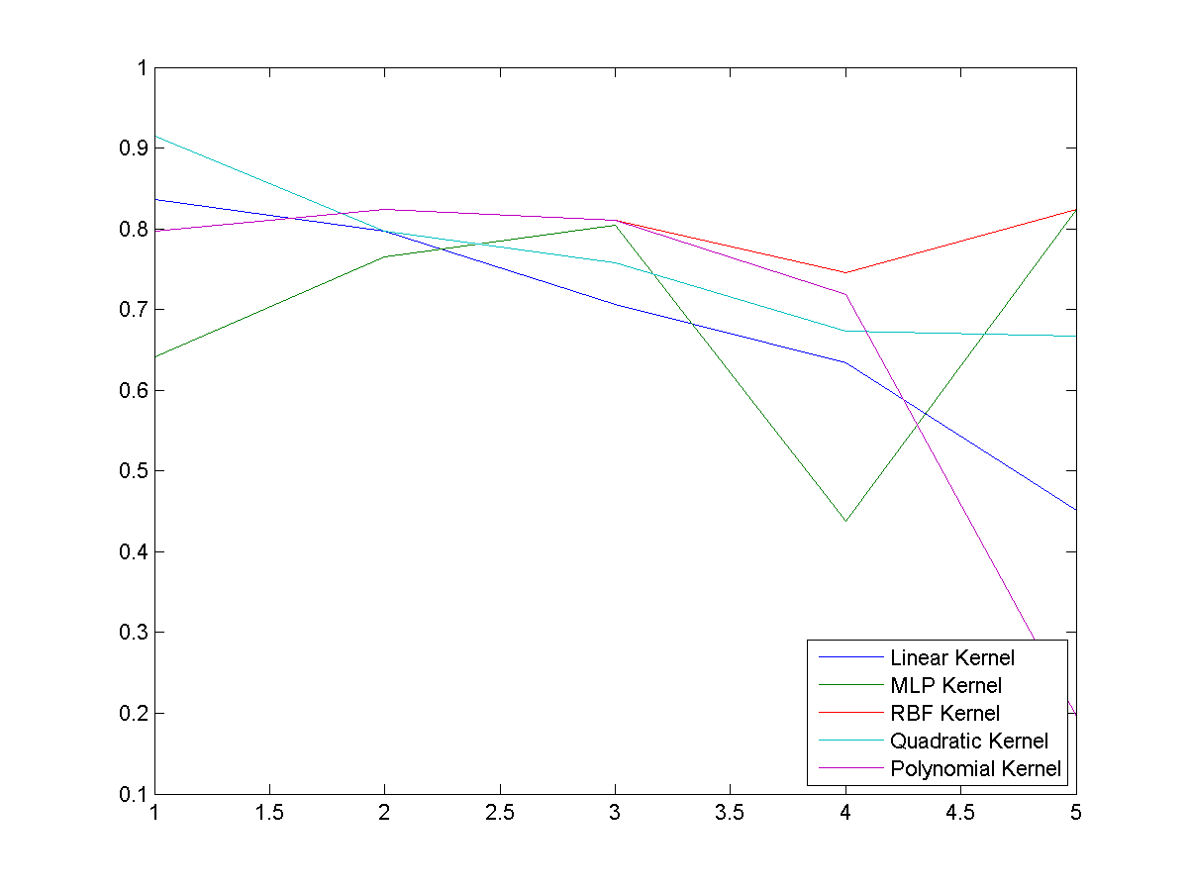 **Figure: Plot of Correctness for various kernels in SVM**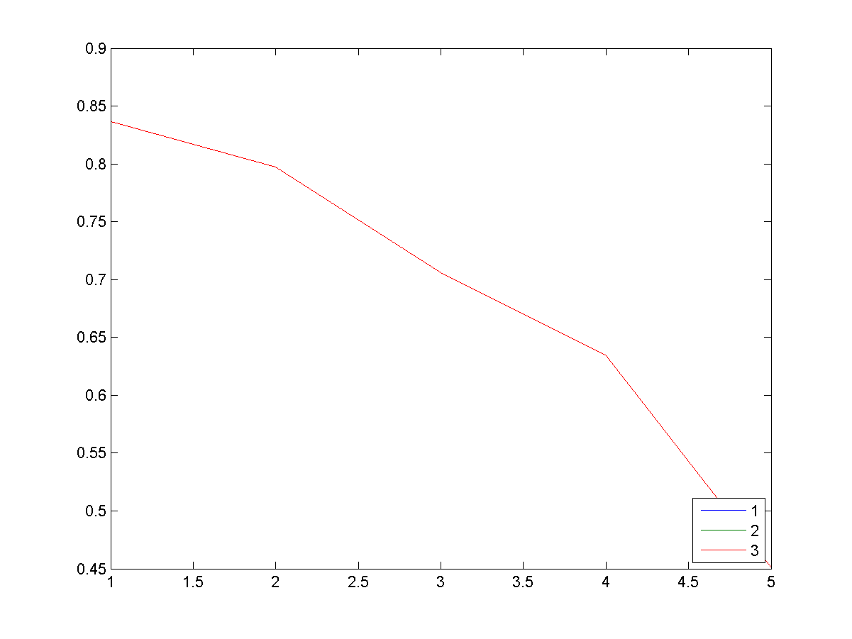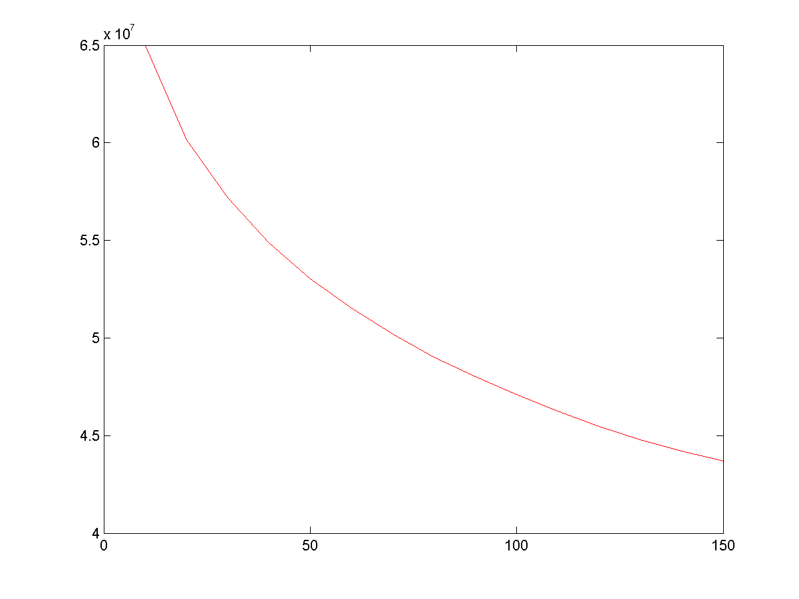

**Figure: Reconstruction Error with Eigenvalues for training images**

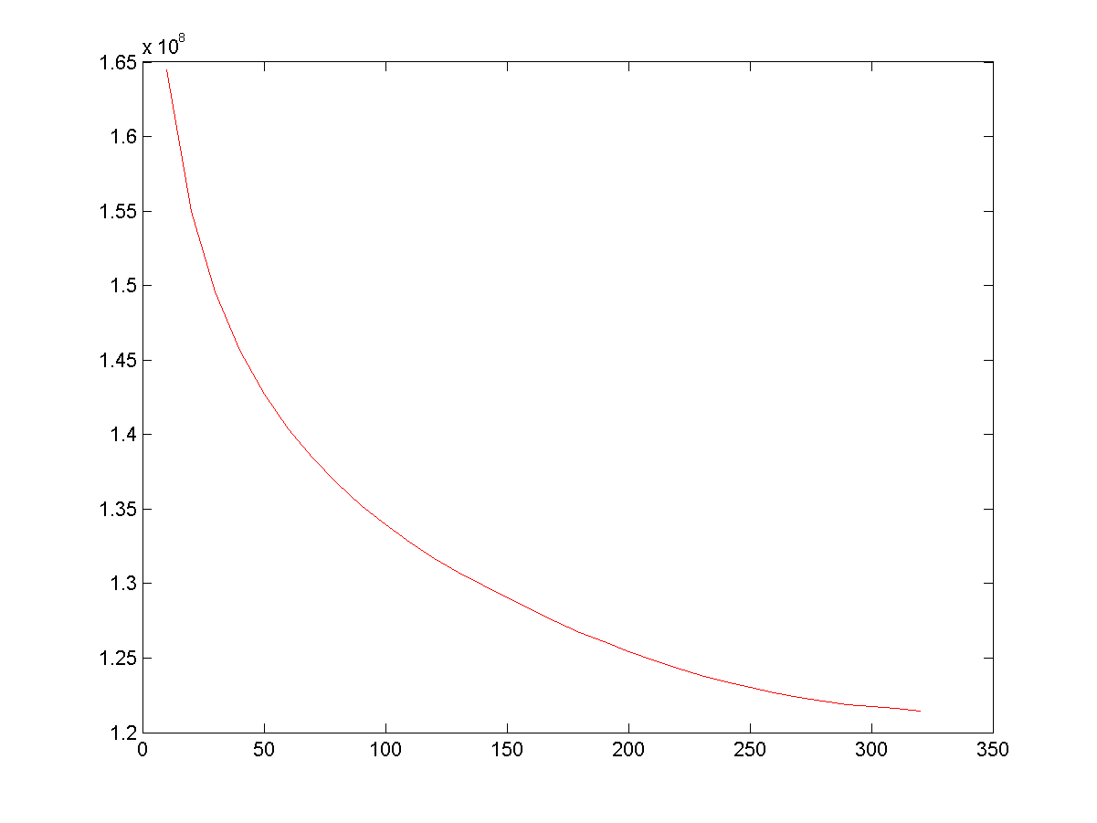

**Figure: Reconstruction Error for different eigenvalues in Test Images**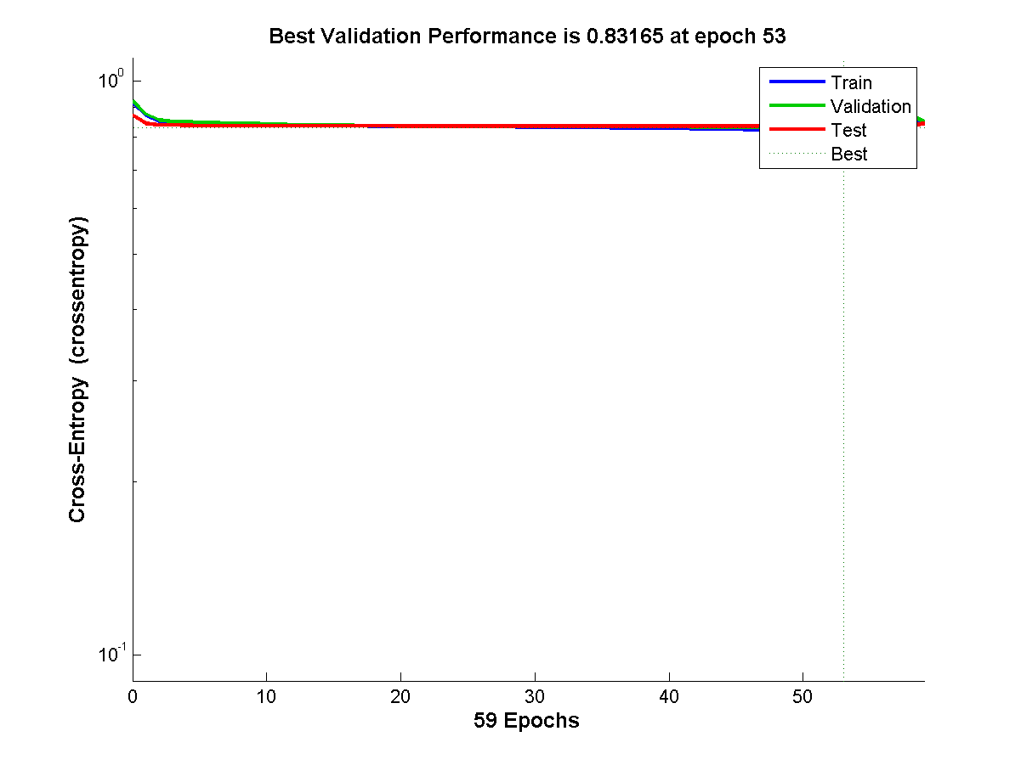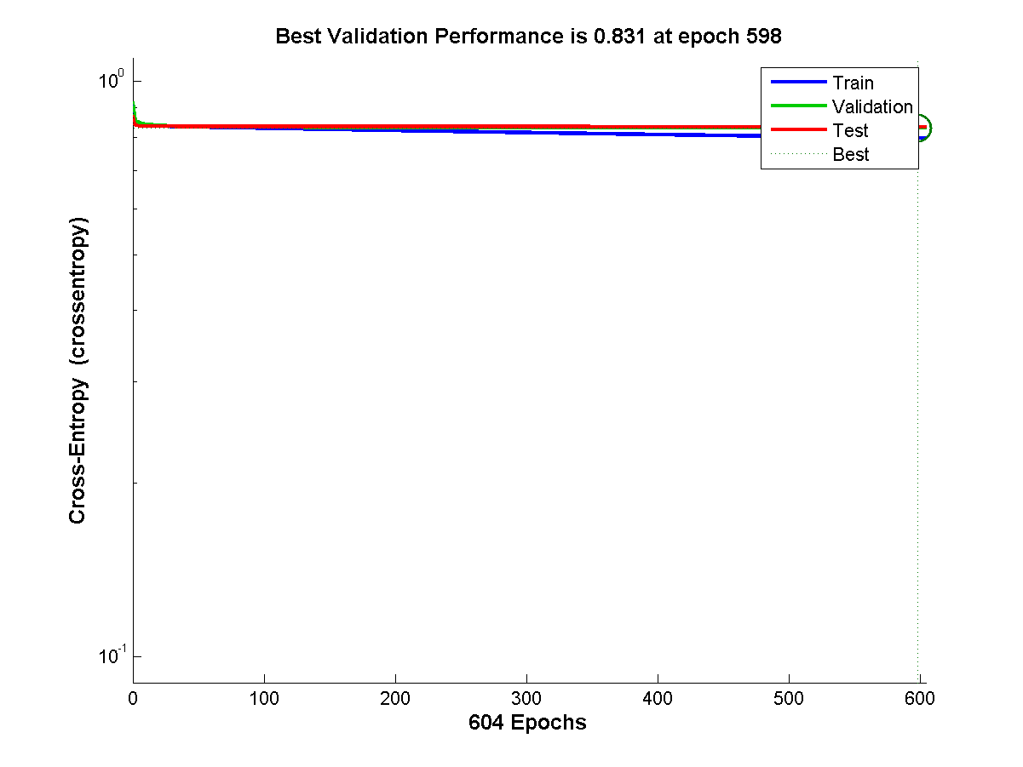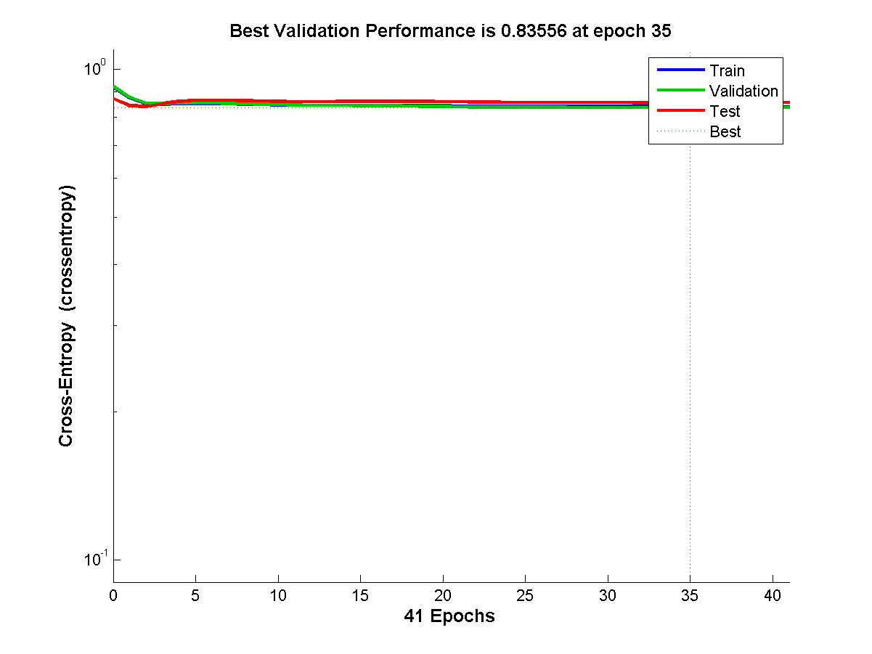

**Figure: traingdx**

